PALMETTO CARE CENTER ACTIVITIES CALENDAR OF EVENTS OCTOBER / 2022
Sunday | Monday | Tuesday | Wednesday | Thursday | Friday | Saturday
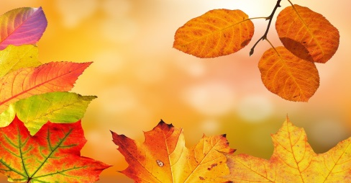 |  | 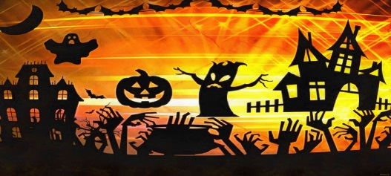 | 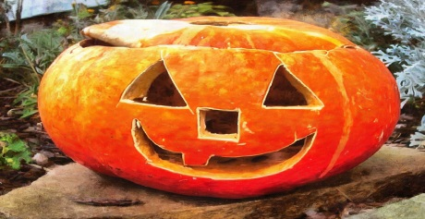 | 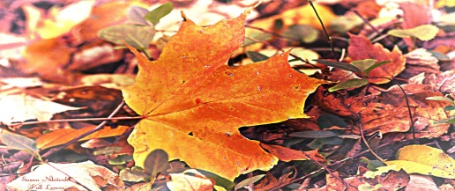 | 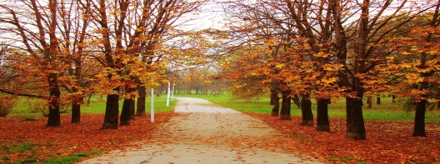 | 1  9:30am Coffee Hour & News  10:30am Activity zone  1:00pm Coffee hour  2:00 Religious Services with La Roca Firme Group
2  9:30am Coffee Hour  10:00am Catholic Mass  1:30pm Coloring and Music  2:30 Table games  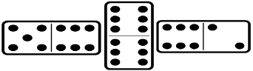 | 3  9:30am Morning Outdoors  10:00am Coffee and News 11:00am Exercise/ in room activities  1:30pm Arts Crafts/ Coffee  2:30pm Table Games | 4  9:30am Morning Outdoors  10:00am Coffee and News 11:00am Exercise/ in room activities  1:30pm Coloring and Coffee  2:30pm Bingo | 5  9:30am Morning Outdoors  10:00am Coffee and News 11:00am Exercise/ in room activities  1:30pm Word Games  2:30pm Table Games | 6  9:30am Morning Outdoors  10:00am Coffee and News 11:00am Exercise/ in room activities  1:30pm Coffee and Music 2:30pm Table Games | 7  9:30am Morning Outdoors  10:00am Coffee and News 11:00am Exercise/ in room activities  2:00PM ICE CREAM SOCIAL | 8  9:30am Coffee Hour & News  10:30am Activity zone  1:00pm Coffee hour  2:00 Religious Services with La Roca Firme Group
9  9:30am Coffee Hour  10:00am Catholic Mass  1:30pm Coloring and Music  2:30 Table Games   | 10  9:30am Morning Outdoors  10:00am Coffee and News 11:00am Exercise  1:30pm Arts and Crafts  2:30Pm Table Games  - Sukkot  - Columbus Day | 11  9:30am Morning Outdoors  10:00am Coffee and News 11:00am Exercise/ in room activities  1:30pm Coffee and Music  2:30pm Table Games | 12  9:30am Morning Outdoors  10:00am Coffee and News 11:00am Exercise/ in room activities  1:30pm Word Games and Coffee  2:30pm Domino/ Bingo | 13  9:30am Morning Outdoors  10:00am Coffee and News 11:00am Exercise/ in room activities  1:30pm Coffee and Music  2:30pm Table Games | 14  9:30am Morning Outdoors  10:00am Coffee and News 11:00am Exercise/ in room activities  1:30pm Coloring and Coffee | 15  9:30am Coffee Hour & News  10:30am Activity zone  1:00pm Coffee hour  2:00 Religious Services with La Roca Firme Group
16  9:30am Coffee Hour  10:00am Catholic Mass  1:30pm Coloring and Music  2:30 Table Games  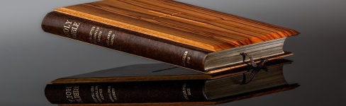 | 17  9:30am Morning Outdoors  10:00am Coffee and News 11:00am Exercises  1:30pm RESIDENT COUNCIL MEETING  2:30pm Arts and crafts   | 18  9:30am Morning Outdoors  10:00am Coffee and News 11:00am Exercise/ in room activities  1:30pm Coloring and Coffee  2:30pm Bingo/ Domino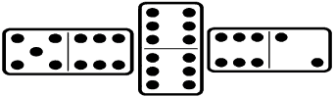 | 19  9:30am Morning Outdoors  10:00am Coffee and News 11:00am Exercise/ in room activities  1:30pm Word Games / Coffee  2:30pm Table Games | 20  9:30am Morning Outdoors  10:00am Coffee and News 11:00am Exercise/ in room activities  1:30pm Arts and Crafts  2:00PM MONTHLY  B-DAY CELEBRATION WITH ENTERTAINMENT | 21  9:30am Morning Outdoors  10:00am Coffee and News 11:00am Exercise/ in room activities  1:30pm Arts Crafts/ Coffee  2:00pm Afternoon Movie | 22  9:30am Coffee Hour & News  10:30am Activity zone  1:00pm Coffee hour  2:00 Religious Services with La Roca Firme Group
23  9:30am Coffee Hour  10:00am Catholic Mass  1:30pm Coloring and Music  2:30 Table Games | 24  9:30am Morning Outdoors  10:00am Coffee and News 11:00am Exercise/ in room activities  1:30pm Arts and Crafts  2:30pm Table Games | 25  9:30am Morning Outdoors  10:00am Coffee and News 11:00am Exercise/ in room activities  1:30pm Coloring and Coffee  2:30pm Bingo/ Domino | 26  9:30am Morning Outdoors  10:00am Coffee and News 11:00am Exercise/ in room activities  1:30pm Word Games/Coffee  2:30pm Table Games | 27  9:30am Morning Outdoors  10:00am Coffee and News 11:00am Exercise/ in room activities  1:30pm Coffee and Music  2:30pm Table Games | 28  9:30am Morning Outdoors  10:00am Coffee and News 11:00am Exercise/ in room activities  1:30pm Arts Crafts/ Coffee  2:00pm Afternoon Movie | 29  9:30am Coffee Hour & News  10:30am Activity zone  1:00pm Coffee hour  2:00 Religious Services with La Roca Firme Group
30  9:30am Coffee Hour  10:00am Catholic Mass  1:30pm Coloring and Music  2:30 table Games | 31  9:30am Morning Outdoors  10:00am Coffee and News 11:00am Exercise/ in room activities  2:00PM HALLOWEEN PARTY & CONTEST WITH ENTERTAINMENT

